FULL ADDER

S = (A $⊕$ B) $⊕CIN$ C = AB + CIN(A $⊕$ B)

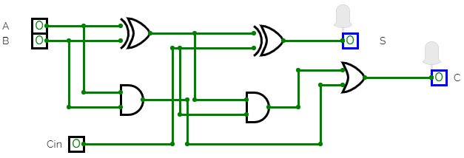

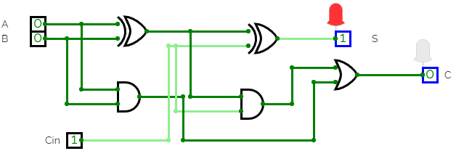

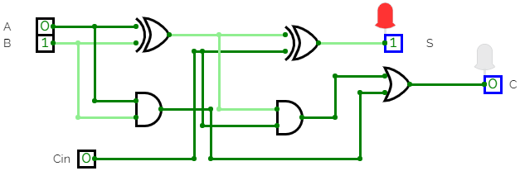

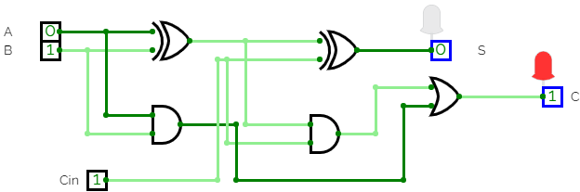

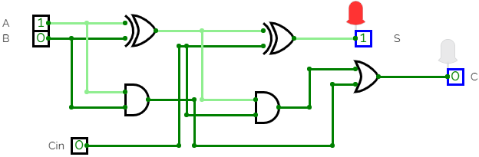

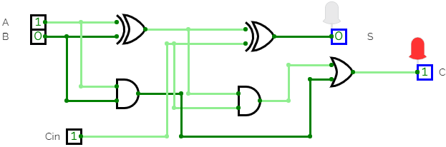

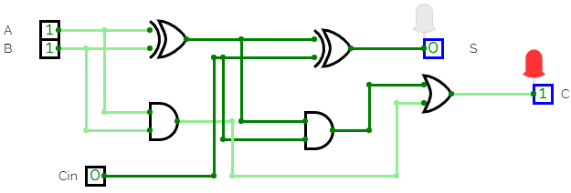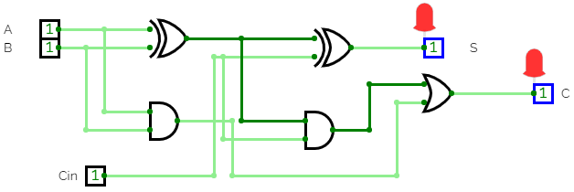

HENCE FULL ADDER IS IMPLEMENTED.